- Average page views
select
avg(Page_Views_Per_Session) as `Average Page Views`
from website_traffic_data

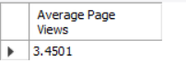

- Avg Session Duration in Hours
select
round(avg(Session_Duration)/3600,2) as `Average Session Duration`
from website_traffic_data

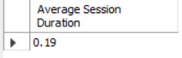

- Total Page Views
select
sum(Page_Views_Per_Session) as `Total Page Views`
from website_traffic_data

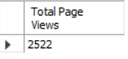

- Total Session Duration in Hours
select
round(sum(Session_Duration)/3600,2) as `Total Session Duration`
from website_traffic_data

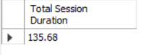

- Total Sessions
select
count(Session_Id) as `Total Page Views`
from website_traffic_data

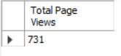

- Bounce Rate
select
(count(Session_Id)/(select count(Session_Id) from website_traffic_data))*100 as Bounce_Rate
from website_traffic_data
where Page_Views_Per_Session <2

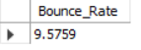

- Bounce Rate by devices
with cte as (
select
d. Device_Type as device1,
count(Session_Id) as Total_Sessions
from device_lookup d
join website_traffic_data w
on d.Device_Key=w.Device_Key
group by d.Device_Type
)
select
d. Device_Type as device_type,
(count(Session_Id)/cte.Total_Sessions)*100 as Bounce_Rate
from device_lookup d
join website_traffic_data w
on d.Device_Key=w.Device_Key
join cte on d.device_type=cte.device1
where Page_Views_Per_Session <2
group by device_type

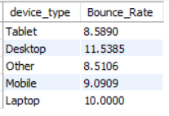

- Bounce Rate by content segment
with cte as (
select
d.Content_Segment as segment1,
count(Session_Id) as Total_Sessions
from device_lookup d
join website_traffic_data w
on d.Device_Key=w.Device_Key
group by d.Content_Segment
)
select
d.Content_Segment as Content_Segment,
(count(Session_Id)/cte.Total_Sessions)*100 as Bounce_Rate
from device_lookup d
join website_traffic_data w
on d.Device_Key=w.Device_Key
join cte on d.Content_Segment=cte.segment1
where Page_Views_Per_Session <2
group by d.Content_Segment

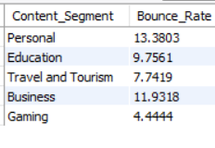

- Bounce rate by Browser
with cte as (
select
d.Device_Browser as browser1,
count(Session_Id) as Total_Sessions
from device_lookup d
join website_traffic_data w
on d.Device_Key=w.Device_Key
group by d.Device_Browser
)
select
d.Device_Browser as Device_Browser,
(count(Session_Id)/cte.Total_Sessions)*100 as Bounce_Rate
from device_lookup d
join website_traffic_data w
on d.Device_Key=w.Device_Key
join cte on d.Device_Browser=cte.browser1
where Page_Views_Per_Session <2
group by d.Device_Browser

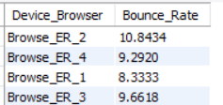

- Bounce Rate by Website Traffic Sources
with cte as (
select
s.Source_Type as source1,
count(Session_Id) as Total_Sessions
from source_lookup s
join website_traffic_data w
on s.Source_Key=w.Source_Key
group by s.Source_Type
)
select
s.Source_Type as Source_Type,
(count(Session_Id)/cte.Total_Sessions)*100 as Bounce_Rate
from source_lookup s
join website_traffic_data w
on s.Source_Key=w.Source_Key
join cte on s.Source_Type=cte.source1
where Page_Views_Per_Session <2
group by s.Source_Type

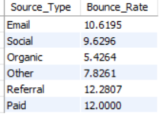

- Bounce_Rate monthly trend
with cte as(
select
monthname(str_to_date(Date_Key, '%m/%d/%Y')) as month1,
count(Session_Id)as total_sessions
from website_traffic_data
group by month1
)
select
monthname(str_to_date(Date_Key, '%m/%d/%Y')) as month,
(count(Session_Id)/cte.total_sessions)*100 as bounce_rate
from website_traffic_data w
join cte on monthname(str_to_date(Date_Key, '%m/%d/%Y'))= cte.month1
where w.Page_Views_Per_Session<2
group by month, month(str_to_date(Date_Key,'%m/%d/%Y')), cte.total_sessions
order by month(str_to_date(Date_Key,'%m/%d/%Y'))

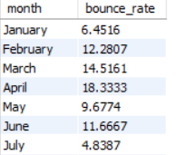

- Bounce Rate daily Trend
with cte as(
select
dayname(str_to_date(Date_Key, '%m/%d/%Y')) as day1,
count(Session_Id)as total_sessions
from website_traffic_data
group by day1
)
select
dayname(str_to_date(Date_Key, '%m/%d/%Y')) as day,
(count(Session_Id)/cte.total_sessions)*100 as bounce_rate
from website_traffic_data w
join cte on dayname(str_to_date(Date_Key, '%m/%d/%Y'))= cte.day1
where w.Page_Views_Per_Session<2
group by day, weekday(str_to_date(Date_Key,'%m/%d/%Y')), cte.total_sessions
order by weekday(str_to_date(Date_Key,'%m/%d/%Y'))

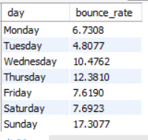

- Average session duration monthly trend
select
monthname(str_to_date(Date_Key,'%m/%d/%Y'))as month1,
avg(Session_Duration)/3600 as average_session_duration
from website_traffic_data
group by month1, month(str_to_date(Date_Key, '%m/%d/%Y'))
order by month(str_to_date(Date_Key, '%m/%d/%Y'))

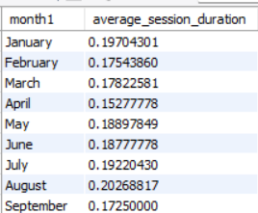

- Average session duration daily trend
select
dayname(str_to_date(Date_Key,'%m/%d/%Y'))as day,
avg(Session_Duration)/3600 as average_session_duration
from website_traffic_data
group by day, weekday(str_to_date(Date_Key, '%m/%d/%Y'))
order by weekday(str_to_date(Date_Key, '%m/%d/%Y'))

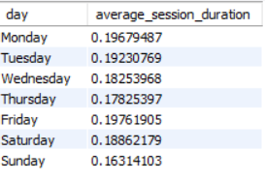

- Total Page views monthly trend
select
monthname(str_to_date(Date_Key,'%m/%d/%Y'))as month1,
sum(Page_Views_Per_Session) as total_Page_views
from website_traffic_data
group by month1, month(str_to_date(Date_Key, '%m/%d/%Y'))
order by month(str_to_date(Date_Key, '%m/%d/%Y'))

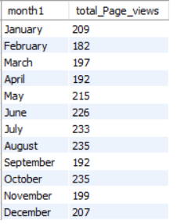

- Total Page views daily trend
select
dayname(str_to_date(Date_Key,'%m/%d/%Y'))as day,
sum(Page_Views_Per_Session) as total_Page_views
from website_traffic_data
group by day, weekday(str_to_date(Date_Key, '%m/%d/%Y'))
order by weekday(str_to_date(Date_Key, '%m/%d/%Y'))

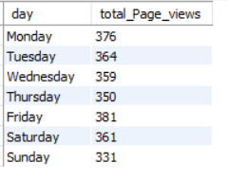

- Total Session Duration in hours by region
select
g.Location_Region as Region,
((sum(Session_Duration)/3600 )/(select sum(Session_Duration)/3600 from website_traffic_data))*100 as total_session_duration
from geo_lookup g
join website_traffic_data w
on g.Location_Key= w.Location_Key
group by Region

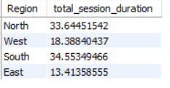

- Total Page Views by region
select
g.Location_Region as Region,
((sum(Page_Views_Per_Session)/3600 )/(select sum(Page_Views_Per_Session)/3600 from website_traffic_data))*100 as total_page_views
from geo_lookup g
join website_traffic_data w
on g.Location_Key= w.Location_Key
group by Region

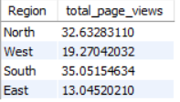

- Bounce Rate by region
with cte as(
select
g.Location_Region as region1,
count(w.Session_Id) as total_sessions
from geo_lookup g
join website_traffic_data w
on g.Location_Key=w.Location_Key
group by g.Location_Region
)
select
g.Location_Region as region,
(count(w.Session_Id)/cte.total_sessions)*100 as bounce_rate
from geo_lookup g
join website_traffic_data w
on g.Location_Key=w.Location_Key
join cte on g.Location_Region=cte.region1
where w.Page_Views_Per_Session<2
group by region, cte.total_sessions
order by bounce_rate desc
limit 5

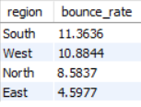

- Total session duration- top 5 cities
select
g.Location_City,
sum(w.Session_Duration)/3600 as total_session_duration
from geo_lookup g
join website_traffic_data w
on g.Location_Key=w.Location_Key
group by g.location_City
order by total_session_duration desc
limit 5

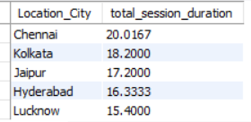

- Total Page Views- top 5 cities
select
g.Location_City,
sum(w.Session_Duration)/3600 as total_session_duration
from geo_lookup g
join website_traffic_data w
on g.Location_Key=w.Location_Key
group by g.location_City
order by total_session_duration desc
limit 5

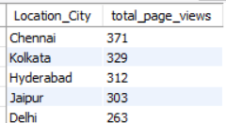

- Total Sessions – top 5 cities
select
g.Location_City,
sum(w.Page_Views_Per_Session) as total_page_views
from geo_lookup g
join website_traffic_data w
on g.Location_Key=w.Location_Key
group by g.location_City
order by total_page_views desc
limit 5

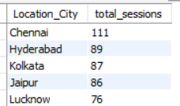

- Bounce rate-top 5 cities
with cte as(
select
g.Location_City as city1,
count(w.Session_Id) as total_sessions
from geo_lookup g
join website_traffic_data w
on g.Location_Key=w.Location_Key
group by g.location_City
)
select
g.Location_City as city,
(count(w.Session_Id)/cte.total_sessions)*100 as bounce_rate
from geo_lookup g
join website_traffic_data w
on g.Location_Key=w.Location_Key
join cte on g.Location_City=cte.city1
where w.Page_Views_Per_Session<2
group by city, cte.total_sessions
order by bounce_rate desc
limit 5

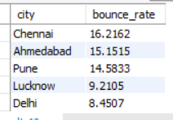

- Total session duration in hours by device type-yearly and quarterly Trend
select
d.Device_type as device_type,
year(str_to_date(Date_Key, '%m/%d/%Y'))as year,
quarter(str_to_date(Date_Key, '%m/%d/%Y'))as quarter,
sum(Session_Duration)/3600 as total_session_duration
from device_lookup d
join website_traffic_data w
on d.Device_Key=w.Device_Key
group by device_type, year, quarter

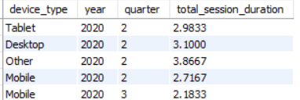

- Total session duration in hours by traffic sources- yearly and quarterly trend
select
s.Source_type as source_type,
year(str_to_date(Date_Key, '%m/%d/%Y'))as year,
quarter(str_to_date(Date_Key, '%m/%d/%Y'))as quarter,
sum(Session_Duration)/3600 as total_session_duration
from source_lookup s
join website_traffic_data w
on s.Source_Key=w.Source_Key
group by source_type, year, quarter

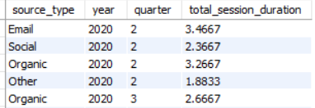

- Total session duration in hours- overall trend
select
year(str_to_date(Date_Key, '%m/%d/%Y'))as year,
quarter(str_to_date(Date_Key, '%m/%d/%Y'))as quarter,
sum(Session_Duration)/3600 as total_session_duration
from website_traffic_data
group by year, quarter
order by year,quarter

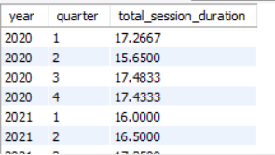

- Average session duration in hours overall trend
select
year(str_to_date(Date_Key, '%m/%d/%Y'))as year,
quarter(str_to_date(Date_Key, '%m/%d/%Y'))as quarter,
avg(Session_Duration)/3600 as avg_session_duration
from website_traffic_data
group by year, quarter
order by year,quarter

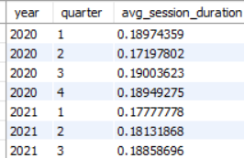

- Total page views overall trend
select
year(str_to_date(Date_Key, '%m/%d/%Y'))as year,
quarter(str_to_date(Date_Key, '%m/%d/%Y'))as quarter,
sum(Page_Views_Per_Session) as Total_page_views
from website_traffic_data
group by year, quarter
order by year,quarter

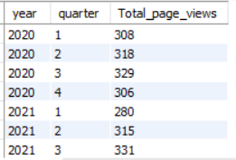

- Bounce rate overall trend
with cte as(
select
year(str_to_date(Date_Key, '%m/%d/%Y'))as year1,
quarter(str_to_date(Date_Key, '%m/%d/%Y'))as quarter1,
count(w.Session_Id) as total_sessions
from website_traffic_data w
group by year1,quarter1
)
select
year(str_to_date(Date_Key, '%m/%d/%Y'))as year,
quarter(str_to_date(Date_Key, '%m/%d/%Y'))as quarter,
(count(w.Session_Id)/cte.total_sessions)*100 as bounce_rate
from website_traffic_data w
join cte on year(str_to_date(Date_Key, '%m/%d/%Y'))=cte.year1 and quarter(str_to_date(Date_Key, '%m/%d/%Y'))=cte.quarter1
where w.Page_Views_Per_Session<2
group by year,quarter, cte.total_sessions
order by year,quarter

